UNIT-V
MS-POWERPOINT

5.1 POWERPOINT BASICS
- Starting PowerPoint
- Click the Start button and select All Programs, then from the sub-menu, select Microsoft Office, then select Microsoft Office PowerPoint 2007.
- When PowerPoint loads you will see the following screen.

Arrangement of Tools in PowerPoint 2007
- The Office Button
- In the top-left corner of the new interface you will find the Office button, which replaces the File menu from previous versions of PowerPoint.
- Click this button to reveal options allowing you to Save and Print files.

- The Quick Access Toolbar
- Situated to the right of the Office button, the Quick Access toolbar holds buttons that can be accessed from all views of PowerPoint.
- Whatever you are currently doing, you will be able to access these commands.
- Initially, the toolbar contains a Save button and Undo and Redo buttons, but you can easily customize the Quick Access Toolbar to hold your favorites commands.

- The Ribbon
- The ribbon contains eight tabs, each relating to a specific task.
- Each tab contains several groups of tools; here the Clipboard, Slides, Font and
- Paragraph groups are visible.
- Each group contains related buttons, menus and lists.

5.2 POWERPOINT FILE MANAGEMENT
- Saving Files
- To save your file, either click the Office button and select Save, or click the save button in the quick access toolbar.
- Specify a name for the file in the File Name box.
- The file name is followed by the extension .pptx. The name helps you identify individual files whereas the extension helps PowerPoint to recognize files that it has been used to create.
- When you have entered a name, click the Save button to save it.

- Closing Files
- If you have finished working on a presentation for the time being, but want to carry on using PowerPoint to edit a different presentation, you should save your work as described above, then click the Office button and select Close from the menu, or click the close button in the presentation window.
- This will close the presentation down but will still keep PowerPoint running.

- Opening Existing Files
- When you want to continue work on a presentation that you started earlier you should click the Office button and select your file from the list in the right column of the menu.
- If your file is not listed, click Open to see the following dialog box.
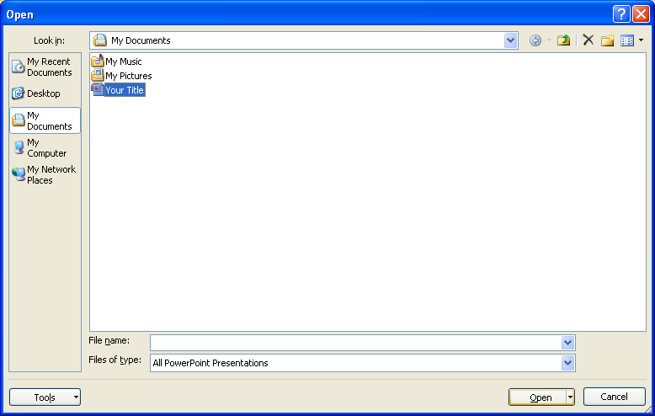

- Creating a Presentation
- When you want to start a new presentation click the Office button and select New from the menu.
- This will give you a new screen with a blank presentation area.
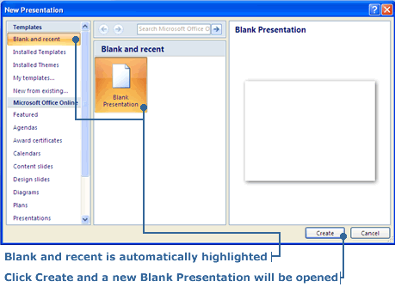

5.3 SLIDES AND POWERPOINT OBJECTS
5.3.1 WORKING WITH SLIDES
- Building Slides
- PowerPoint presentations consist of a series of slides.
- In building up a presentation you construct each slide adding titles, list points, and graphics as necessary. You can either start with a blank slide, or start with a template with ready-made entries for titles, lists and graphics.
- With PowerPoint loaded, you can build your first slide. To add a title to your slide click on the text labeled Click to add title. As soon as you click, the text will disappear and be replaced by a flashing insertion point.
- To add a new slide to your presentation, from the Slides group on the Home tab, click the top of the New Slide button to add a general slide.
- Alternatively, click the bottom of the New Slide button to reveal a menu of slide designs.
- You will see a collection of slide themes, which contain various combinations of titles and content.
- Slide Layout
- The slide layouts help define the position of tides, subtitles, text, content and objects in the slide.
- The first slide you will see when PowerPoint opens is the Tide Slide layout.
- To choose additional slide layouts:
Step 1. Go to the Home tab on ribbon at the top of the screen
Step 2. Select Layout icon and click on the arrow to see Office Theme dialogue box
Step 3. Choose a theme to match your content
Step 4. Input content into designated text boxes. Adding extra text boxes to predefined layouts will disorganize reading order for a screen reader

- Animation and Design
- Now that we have covered the construction of slides, we can transform the information into an elegant presentation.
- Whilst doing this it is useful to click the Slide Show tab to check how the slides would appear in a real slide show.
- To look at the current slide, as it would appear in the show, click the From Current Slide button in the Start Slide Show group.
- To view all slides from the beginning click the From Beginning button in the Start Slide Show group.
- When you wish to return to the normal view press the Esc key.

- Design Templates
- To apply a design template to your presentation, go to the Design tab.
- In the Themes group, click the bottom button in the column of three to see the available designs. Click any theme to apply it to all slides in your presentation.

- Modifying the Theme
- Once you have applied a theme, you can modify it using tools in the Design tab.
- In the Themes group there are three buttons that let you change the Colors, Fonts and Effects used in the chosen theme.
- Click any button to reveal a menu of options.
- In the Background group is a Background Styles button, which lets you modify the style of the background used in the theme.

- Transitions Between Slides
- As you move from slide to slide during the presentation, you can have PowerPoint display an animated effect.
- To choose an effect, go to the Animations tab.

- In the Transition to This Slide group, click the bottom button in the column of three to the right of the palette.
- Click any transition to see the effect played out on your presentation slides in the background.
- When you have chosen an effect it will work when you move to this current slide.
- You can have the effect work on every slide in your presentation by clicking the Apply to All button.
- Animated Bullet Points
- To increase suspense in your presentation and to keep your audience focused on the current issue you can introduce points on a slide one at a time.
- To do this go to the Animations tab, and in the Animations group, click Custom Animation button. A pane will appear.
- Your slide may have a title, some text and a graphics object, select any object that you wish to be animated, then click the Add Effect button
- In the menu structure, choose an animation effect for the entrance of each component of your slide.
- In the right-hand pane, you can then specify the speed and direction of the animation.
- Using the list at the bottom of the pane you can reorder the animation to ensure that the slide components appear in the correct order.

5.3.2 WORKING WITH POWERPOINT TEXT OBJECTS

Add text with Text Boxes | Home Tab >> Drawing >> Text Box OR  Insert Tab >> Text >> Text Box  - Click on the Text Box button - Choose Horizontal TextBox  - In the slide, click-and-drag the mouse to draw a TextBox  - Drag circle corner points or square side points of the text box to change its size.  - Click within the TextBox to type text.
Format a Text Box | Drawing Tools Tab - Format >> Shape Styles  - Select the Text Box. The Drawing Tools Tab appears.  - Click on the Format Tab. Format the selected Text Box in Shape Styles:  - Shape Fill - Changes the fill color  - Shape Outline - Changes the color, width, line style of outline  - Shape Effects - Applies visual effects (shadow, bevel, etc.)
Add WordArt - fancy text | Insert Tab >> Text >> WordArt  - Click on the WordArt button >> Select the style you like  - A WordArt Text Box appears in the slide. Type in.
Group, Align and Rotate shapes | - While holding the shift key, click on the objects you wish to group. Drawing Tools tab appears.  - Click on Format tab.  - To group the objects: Click on Group button in Arrange Group  - To align the objects: Click on Align button in Arrange Group  - To rotate the objects: Click on Rotate button in Arrange Group  Shapes in a group my still be moved and edited individually, and will continue to correspond to their group after being changed.
Add an image from a file | Insert Tab >> Illustrations >> Picture  - Find the picture file you want to insert in the browser window.
Add an image from Clip Art | Insert Tab >> Illustrations >> Clip Art  - Search for ClipArt and other media in the right-hand search panel.  - Check in "Everywhere" box under "Search in" for more extensive results

5.4 MULTIMEDIA

5.4.1 INSERTING SOUND FILES

To insert a sound file from your computer
- Select the slide where you want to add sound.
- Select the Insert tab.
- Click the drop-down arrow on the Sound command in the Media Clips group.
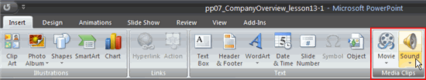
- Select Sound from File from the menu. The Insert Sound dialog box will appear.
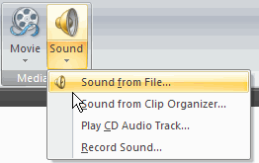
- Locate the sound file on your computer.
- Select the file.
- Click OK. A sound icon and a dialog box will appear.
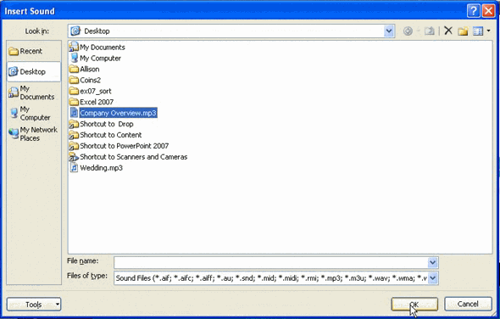
- Select Automatically or When Clicked. Automatically will start the sound automatically as soon as the slide appears in Slide Show view, while When Clicked will start the sound when you click.
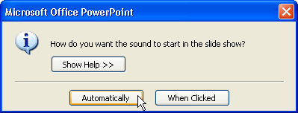
- Click, drag, and release the button to move the sound icon to a different location on the slide.
Sound options
- On the Sound Tools Options tab, there are several options you can control that determine how the sound is used in the presentation. These include:
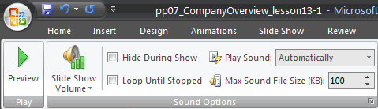
- Preview: Listen to the sound that will play
- Slide Show Volume: Change the volume to low, medium, high, or mute
- Hide During Show: Hide or display the sound icon during the slide show
- Loop Until Stopped: Have sound play until you stop it by clicking or advancing to the next slide
- The Picture Tools Format tab appears when a sound is inserted because the sound icon is a picture. You can format the sound icon just like any picture.

To delete the sound
- Select the sound icon.
- Press the Delete key on your keyboard.

To insert a sound from the clip organizer
- Select the slide where you want to add sound.
- Select the Insert tab.
- Click the drop-down arrow on the Sound command in the Media Clips group.
- Select Sound from Clip Organizer from the menu. The Clip Art task pane will appear.
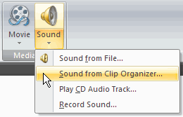
- Enter keywords in the search field.
- Click Go. Clip art sound results will appear in the task pane.
- Click a sound file in the task pane to insert it. A sound icon and a dialog box will appear.
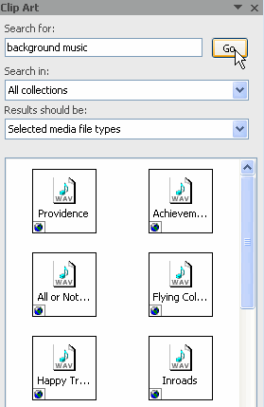
- Click Automatically or When Clicked. Automatically will start the sound automatically as soon as the slide appears in Slide Show view, while When Clicked will start the sound when you click.

To preview sound from the clip organizer:
- Enter keywords in the search field.
- Click Go. Clip art sound results will appear in the task pane.
- Move your cursor over a sound option, and a drop-down arrow will appear.
- Click the drop-down arrow.
- Select Preview/Properties from the menu. The sound file will play, and a dialog box will appear.
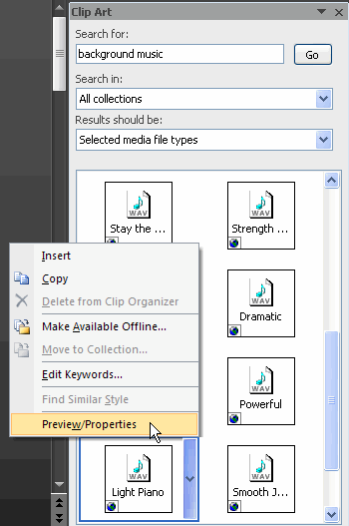

About the Preview dialog box
- Information on the right includes file name and type.
- Use the sound controls to play, pause, and stop the sound file.
- The name of the current sound file is to the right of the word Caption, below the sound controls.
- Click the Next and Previous arrows to open and listen to an additional sound file.
- Click the Close button to close the dialog box. The last active sound file appears selected in the Clip Art task pane.
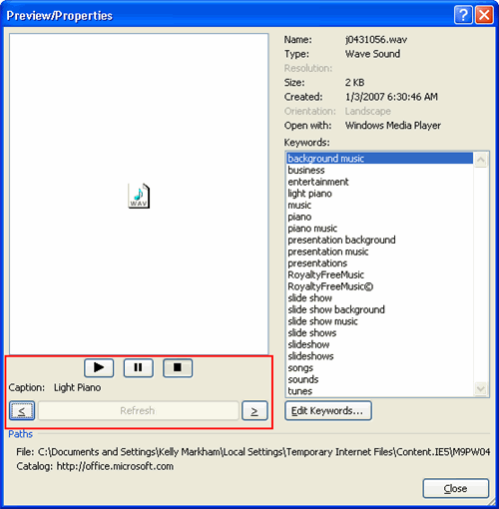
- Insert the sound file if you want.

Sounds on CD

To play tracks from a CD:
- Select the Insert tab.
- Click the drop-down arrow on the Sound command.
- Select Play CD Audio Track from the menu. The Insert CD Audio dialog box will appear.
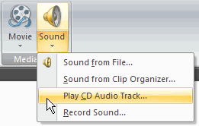
- Enter the Start at track: and End at track: information in the Clip selection section.
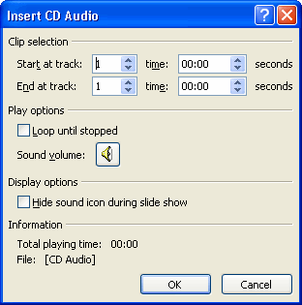
- Choose whether you want to Loop the tracks until stopped and adjust the volume in the Play Options section.
- Choose to display or hide the sound icon during the slide show in the Display Options section.
- Click OK. A CD sound icon and a dialog box will appear.
- Select Automatically or When Clicked.
To add sound from a CD, you must have a music CD inserted into your computer's CD-ROM drive.

The CD Audio Tools Options tab
Once you have inserted tracks from a CD, a CD Audio Tools Options tab appears. Many of the commands are similar to the commands available when you insert other sounds; however, some of the options are different.
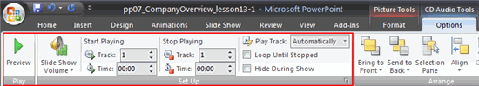
Functions in the Play and Setup groups include:
- Preview: Listen to the sound that will play
- Slide Show Volume: Change the volume to low, medium, high, or mute
- Edit the Track and Time fields: Change the tracks that play and the time in the track that playback starts or stops
- Change How to Play Track: Click the drop-down menu next to Play Track to change whether the CD tracks play automatically or when clicked
- Hide During Show: Hide or display the sound icon during the slide show
- Loop Until Stopped: Have sound play until you stop it by clicking or advancing to the next slide
5.4.2 ADDING VIDEO

To insert a movie from a file on your computer
- Select the slide where you want to insert the movie.
- Select the Insert tab.
- Click the drop-down arrow on the Movie command in the Media Clips group.
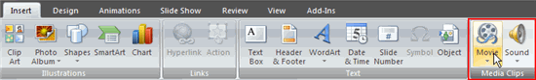
- Select Insert a Movie from File from the menu. The Insert Movie dialog box will appear.
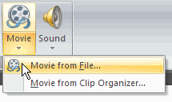
- Locate the file you want to insert from your computer.
- Click the file name.
- Click OK. The movie will appear on the slide. The Movie Tools Options tab and Picture Tools Format tab appear on the Ribbon when the movie is inserted.
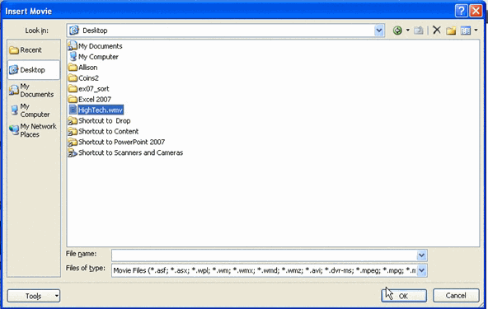
- A dialog box will appear. Click Automatically or When Clicked. Automatically will start the movie automatically as soon as the slide appears in Slide Show view, while When Clicked will start the movie when you click.
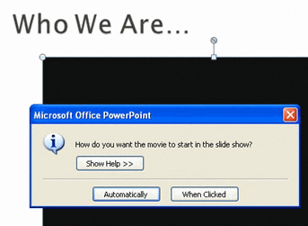
- Sizing handles are located around the movie. Click, drag, and release the resizing handles to resize the movie.
- The sizing handles work the same here as with pictures, text boxes, and shapes.
- If a slide layout has a content placeholder, click the Insert Media Clip command to insert a movie located on your computer.

Working with movies

To preview the movie:
- Select the movie on the slide.
- Select the Options tab.
- Click the Preview command in the Play group.
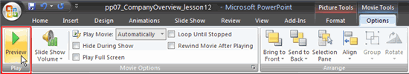
- Press the Preview command again to stop the movie before it finishes playing.

To change the movie volume:
- Select the movie on the slide.
- Select the Options tab.
- Click the Slide Show Volume command in the Movie Options group.
- Select low, medium, high, or mute to change the movie volume.
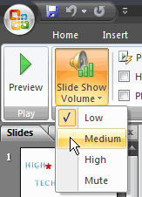

To change when the movie starts:
- Select the movie on the slide.
- Select the Options tab.
- Select the drop-down menu next to Play Movie: in the Movie Options group to change whether the movie plays Automatically or When Clicked.
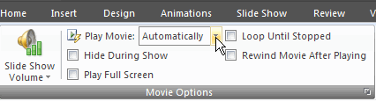

Other options
Click a box to select and deselect movie options on the Movie Tools Options tab. These options include:
- Hide During Show
- Play Full Screen
- Loop Until Stopped
- Rewind Movie After Playing
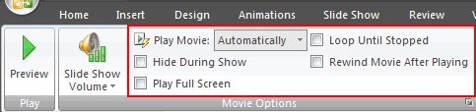

Picture Tools Format tab
Many of the commands on the Format tab cannot be used to modify the video in a significant way; however, a picture style can be applied to the movie.
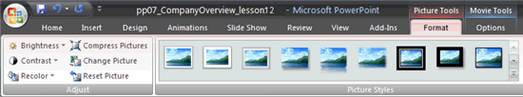

Inserting movie clips

To insert a movie from the clip organizer:
- Select the slide where you want to insert a movie clip.
- Select the Insert tab.
- Click the Movie command in the Media Clips group.
- Select Movie from Clip Organizer from the menu. The Clip Art task pane will appear on the right.
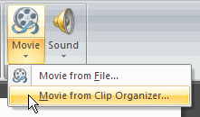
- Enter keywords in the search field.
- Click Go. Movie clips that meet the keyword search will appear in the task pane.
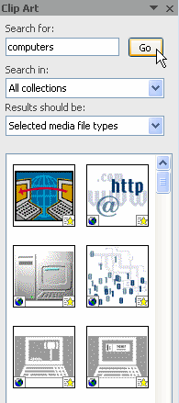
- Click a clip to insert it. The clip will appear on the slide.
- Movies in the clip organizer are similar to animated picture files. You can select Office Online at the bottom of the Clip Art task pane to view additional movie clips.

To delete a media clip:
- Select the movie from your computer or the clip organizer.
- Click the Delete key.

